LIBRARY MANAGEMENT SYSTEM:

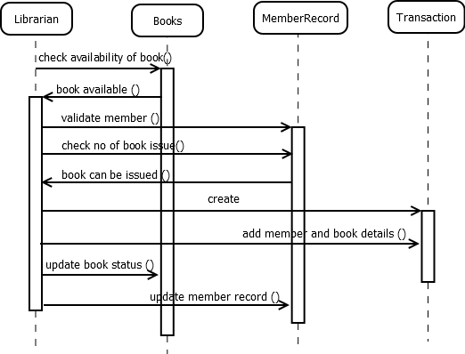

ONLINE FOOD ORDERING SYSTEM:

